**Business on Cloud**

**What to choose, How to Choose the Service**

**Comparison of Cloud Services.**

**Deepthi Thalagundamatada**

**Dr. Dev Simmonds**

**CSC 550 Software Engineering**

Abstract

**Current Businesses are taking a steep trend of moving to the cloud which could be termed as Cloud computing. This Paper guides business towards which service to choose according to the Cloud Computing models which would be necessarily needed for the business. Comparison is done based on the Computing Models IaaS, SaaS, PaaS and the service providers available in the market. Impact on the business of the companies which choose these cloud computing services will be Discussed. Comparative study upon deploying sample application on Amazon Web Services and Microsoft Azure which are compotators among the Service providers. Paper also gives insights on the current trend of the cloud services according to the industry size.**

# 1. Introduction

There has been a wide improvement in the IT and it has seen its steep growth towards the Cloud. The infrastructure, Platform, and Software maintenances have become handier. The service vitality, elasticity, choices and flexibility offered by this scalable technology are striking that makes the cloud computing to increasingly becoming an integral part of the enterprise computing environment. Startups are trendy as one can start a company with a 98% reduction in initial investment cost compared to the Decade ago.

The computing and deploying the application on the cloud-based server has become common even enterprise MNCs are moving towards these cloud infrastructures. Because of the cloud, the business start-up becomes cheaper and reliable. Anyone who wants to set up the business or the enterprise who want to move to the cloud must do research on which service is better in the market and what platform is best suited. Later this phase would be POC which is called Prof of the concept of moving towards the cloud.

If the industry is Large and has Tie-ups with a lot of other software in the industries for which they have to even consider the suitable support and platform which could be a good fit for their existing system. If they are medium and small scale industry there will need to consider the budget and minimal cost consumption platform which their existing or the new system would need. If the business is a startup and they need to know and research on lot of probabilistic that how to run their startup, What they need, How they need and what they until when they need the service and for the business and the platform is to be considered as global or is it needs it to be in some specific region. Then they must consider the platform and the cost of the cloud.

[2]Cloud computing is a way to increase the capacity or add capabilities dynamically without investing anything new in infrastructure, training new personnel, or licensing new software.

So This paper is a small effort which is made towards to understand the cloud computing structure and the resources available, current market trends, Comparison of them with various aspects, along with how to deploy a small application on the cloud. This paper can give real insights on how to choose your service of cloud infrastructures

# 2. Background and Related Works

Cloud computing Definitions:

“*A Cloud is a type of parallel and distributed system consisting of a collection of inter-connected and virtualized computers that are dynamically provisioned and presented as one or more unified computing resource(s) based on service-level agreements established through negotiation between the service provider and consumer*”[14][15]

IlangoSriram et al[6]. go through more definitions of cloud computing and proposed the following definition: “*Clouds are a large pool of easily usable and accessible virtualized resources (such as hardware, development platforms and/or services).”*[5][6]

According to Peter Balco*, Jehuda Law, Martina Drahošová the definition of cloud computing is [1] “*Cloud computing services are presenting very simple approaches to buy IT needs from various technology providers. Existing cloud computing services cover a wide spectrum of items including infrastructure, platforms or different spectrum of business applications.*”

Eugene Gorelik [6] proposed that: “*Cloud computing begins with a huge IT transformation in history, and this transformation has opened many new business opportunities. It is expected that public Cloud Computing enables to have universal, convenient, on-demand network access to a shared pool of configurable computing resources (e.g., networks, servers, storage, applications, and services)”*

Santosh Kumar and R. H. Goudar [7] states that “ *Cloud Computing is the development of parallel computing, distributed computing, grid computing, and is the combination and evolution of Virtualization, Utility computing, Software-as-a-Service (SaaS), Infrastructure-as-a-Service (IaaS) and Platform-as-a-Service (PaaS)”.*These can be maintained easily and needless effort in understanding and setting up the service provider interaction.

As per the Yashpal sing et al.[8] “*the characteristics of the Cloud model On-demand and self-service are some of the characteristics of the Cloud model. The services can be obtained without human intervention and the services are provided by simple logging through*

*the user account.*”

* Pay-per-use character makes it popular in organizations which needs short period services rather than long term or permanent service. Therefore, one pays only when one uses the service
* Device and location independency makes it accessible from a different location and different machines.
* Rapid elasticity in Cloud Infrastructure denotes capabilities to provide new services to

a consumer with different platform specifications.

The cloud itself consists “of a collection of interconnected and virtualized computers that are dynamically provisioned and presented as one or more unified computing resource(s)” [10].

This cloud model is composed of

* **five** essential characteristics
* **three** service models
* **four** deployment models

**Essential Characteristics:[3][5]**

1. *On-demand self-service:*

A consumer can separately choose the computing capabilities, such as server time and network storage, as needed automatically without requiring human interaction with each service provider.

1. *Broad network access:*

This enables to have network and network and accessed through standard mechanisms that promote use by heterogeneous thin or thick client platforms (e.g., mobile phones, tablets, laptops, and workstations).

1. *Resource pooling:*

multiple consumers are served by the provider’s computing resources which are pooled using a multi-tenant model, with different physical and virtual resources dynamically assigned and reassigned according to consumer demand. Customers can have the resources independent of the location which means they do need not know where exactly the server locates and the resources, but they know on the higher level like country and the region of the server and data center along with some specifications like memory network bandwidth, Processors resources, etc

1. *Rapid elasticity.*

The appropriate capabilities for the system need the upgradation from time to time depending upon the business they customer cloud-based Applications) need services. So there must be a correct measure to inculcate the rapid growing demand along with the necessities which appear to be in any quantity at any time which means the user(application) must be given the unlimited expansion along with automatic upgradation.

1. *Measured service.*

Resource optimization and controlling them is done by cloud automatically. Consumers are charged by a meter which is set at some level of abstraction to the type of service (e.g., storage, processing, bandwidth, and active user accounts). Resource usage can be monitored, controlled, and reported, providing transparency for both the provider and consumer of the utilized service.

**Service Models:[3][5]**

* SaaS
* PaaS
* IaaS

***Software as a Service (SaaS).***

The users are provided with all the underlying facilities of cloud infrastructure including network, servers, operating systems, storage, or even individual application capabilities, with the possible exception of limited user-specific application configuration settings. The software on the top of these layers which is implemented is given to the consumer in such a way that they can remodify some structures and appearance in the application and use them for their specific business needs.

**Features of SaaS-**

1. Can manage applications on a strong network and access to licensed software at low costs.

2. Follows Multitenancy model.

3. Customer specific enhancements of the software.

**Advantages of SaaS are:**

1. Easily available software reduces the time required for application development.

2. Increases the availability of the applications globally.

3. Data consistency and compatibility across the company/organization/enterprise.

4. These applications are scalable and flexible.

5. The updated versions of the SaaS software are looked after by the service providers.

***Platform as a Service (PaaS)*:**

The customer is provided with the platform on the cloud with the necessities with some particular (programming languages, libraries, services, and tools) which are supported from the cloud and are needed to host their website or the application are provided to them

The consumer does not have to manage or control the underlying cloud infrastructure which includes network, servers, operating systems, or storage, but necessary controls over the applications which are deployed along with configuration settings for the application-hosting environment.

**PaaS consists of three main components [13]**

1. Stack
   * This component which is needed for backend implementation [language virtual machine, servers, databases load balancers, caching mechanism, etc.] are inside the Stack
2. Deployment Machinery
   * This contains the Scripts and services which are necessary for deploying the applications on the internet.
3. User Experience
   * Front end development components which are needed such as user interface, customized abstraction, flexibility to choose the environments and design.

**Advantages of Paas are:**

1. This can deploy the application which is developed using Agile

2. Infrastructure and cost of maintaining it and buying hazels are removed upon which the company can concentrate on the important resources for the enterprise

3. Platforms provided are updated regularly thus the applications which are built are done using the best technologies available and with less worry about the security issues related to upgrades

4. Using PaaS one can improve productivity and minimize the development time

5. The developer need not have complete knowledge about the backend process and platform environment of the cloud.

***Infrastructure as a Service (IaaS)****. [12]*

The customers are provided with the necessary Infrastructures which are essentially needed to develop and deploy the software in IaaS. Here the customers can even choose the environment which the application they want to run. Along with processing, storage, networks they will provide the consumers operating systems and applications with fundamental computing resources. consumers can have control over operating systems, storage, and deployed applications bit possibly limited control of select networking components (e.g., host firewalls).

[5]The general virtual components which can be offered by IaaS are-

1. Computer Hardware

2. Computer Networks (such as routers, firewalls, load balancers, etc.)

3. Internet Connectivity (using optical carriers)

4. Platform virtualization environment for running client-specified virtual machines.

5. Service level agreements

**Advantages of IaaS are: [5]**

1. promotes efficient IT services enabled by the readily available environment, customized for the client,

2. Maintenance has become more convenient and readily available on the internet.

3. The burden of high-cost maintenance cost for the hardware is reduced.

4. Data storage and leakage complexities are reduced and data can be recovered in case of any failure of host allocation.

5. Virtual instances are provided upon the demand and necessity

6. outsourcing of the Virtual instances like servers, operating systems, networks can be done with the benefit of rental

**Deployment Models: [9]**

*Private cloud:*

It may be owned, managed, and operated by the organization, a third party, or some combination of them, and it may exist on or off premises. The cloud infrastructure of specific usage is provided by a single organization which consists of multiple consumers.

*Community cloud.*

It may be owned, managed, and operated by one or more of the organizations in the community, a third party, or some combination of them, and it may exist on or off premises. The infrastructure is provided for use by a specific community of consumers from organizations that have shared concerns

*Public cloud.*

It exists on the premises of the cloud provider. It may be retained, managed, and operated by a business, academic, or government organization, or some combination of them. The infrastructure is provided for open use by the public.

*Hybrid cloud*.

The cloud infrastructure is a composition of two or more distinct cloud infrastructures (private, community, or public) which can remain as a separate entity but can be brought together by standardized or proprietary technology that enables data and application portability.

**Some of the SaaS service providers are:**

1. Salesforce CRM from Salesforce.

2. Oracle CRM from Oracle On-Demand from Oracle.

3. SAP ERP and SAP CRM by SAP Business By Design from SAP.

4. SaaS applications and services from Cloud9 Analytics.

For IaaS and PaaS below are the examples from the major companies.

|  |  |  |
| --- | --- | --- |
| **Providers/Models** | **PaaS** | **IaaS** |
| Google | Google App Engine | Google Compute Engine |
| Microsoft | Windows Azure | Azure Virtual Machines |
| AWS | Amazon Elastic Bean stack | Amazon elastic compute |

# 3.Experimental Design

Main Goal of the paper is to show the comparison of the services. The Sample application has been deployed on the clouds. Based on the preliminary research I consolidated to experiment on AWS, Azure, and Google.

AWS a have free Tier and it varies upon the services and it is the same for Azure and Google.

**Microsoft Azure[17]**

**Steps to set up and deploy the application:**

I have implemented web application on the Visual Studio publish on the Cloud in real time with Azure and a serverless application in aws using aws Lambda as beanstack was complex and priced high I choose AWS Lambda.

*Deployment in Azure*

Creating the Sample application on .NET(Visual Studio)

Prerequisites:

Visual Studio 2017 with ASP.NET and Web Development Workload

Step 1:In the Visual Studio 2017 create a new project by selecting

**Visual C# > Web > ASP.NET Core Web Application.**

Give the name for the application

Step 2:Select Web application

Default Web application will be launched which is essential and a required to deploy either on Azure.The default application can be modified as required before the deployment

To publish your application on the Cloud. First Step is to Develop the application on Visual Studio. I did web application on Visual studio for deploying on cloud. The application was all set to launch. Now I created the Service in the Azure environment to have the Resource to launch my application.

A [resource group](https://docs.microsoft.com/en-gb/azure/azure-resource-manager/resource-group-overview#terminology) is a logical container into which Azure resources like web apps, databases, and storage accounts are deployed and managed. For example, you can choose to delete the entire resource group in one simple step later.

Configure the Hosting Plan: Choose Service plan, Location, and Size

Now create the App name to launch, Select the Resource group Created and hosting Server location then opt for creating. It takes a while to upload.

Important to note is we can configure the deployment type. We can choose either continuous deployment or the deployment to the server passing by the staging area. Staging is the area where the website will be published but will be in a test environment. When Test Team is done with the Testing and the application is set to deploy than the company can deploy the Code to the Server to have the Changes.

**Deployment on aws Lambda:[16]**

I Choose to deploy a serverless application on the AWS cloud to see the easier way to maintain and deploy your own website. A serverless application can be deployed on Aws using various technology like a .net visual studio and by using the IDE which is provided by Aws itself.

I have used Lambda instance with AWS CodeStar and AWS Cloud9 for deploying sample serverless application.

Steps to be followed:

Pre-requites:

Create the free tire account on aws cloud and be care full and keep track of the charges and services in the billing section.

Step 1: Navigate to CodeStar

Step 2: Build a simple NodeJS app in CodeStar

* select Start a project.
* Create a service role
* Choose a project template
* Give Project details
* Review project details and create the project.
* Set up tool to aws cloud9 with t2 instance[free instance]

Step 3: Change Then Deploy Your Application

* Go to IDE and give the command in the console
* cd /home/ec2-user/environment/demoapplicationForSE
* Do the required changed in the HTML pages and then save
* Get the status by git status command
* Commit and publish using the commands
  + git add public/index.html
  + git commit -m "changed a sentence here"
  + git push origin master

Step 4: Terminate Your Resources after to not to be billed for the resources.

# 4. Results

**Insights on Deployment Azure:**

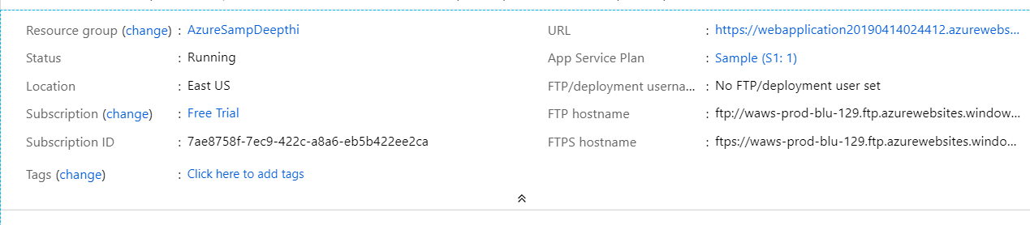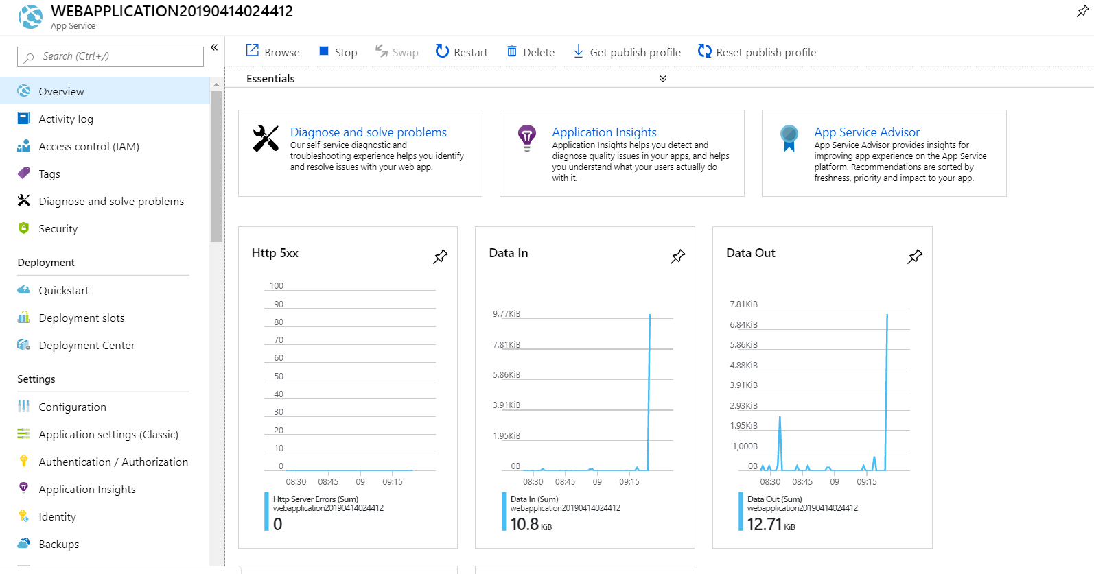

**Insights on Deployment AWS:**

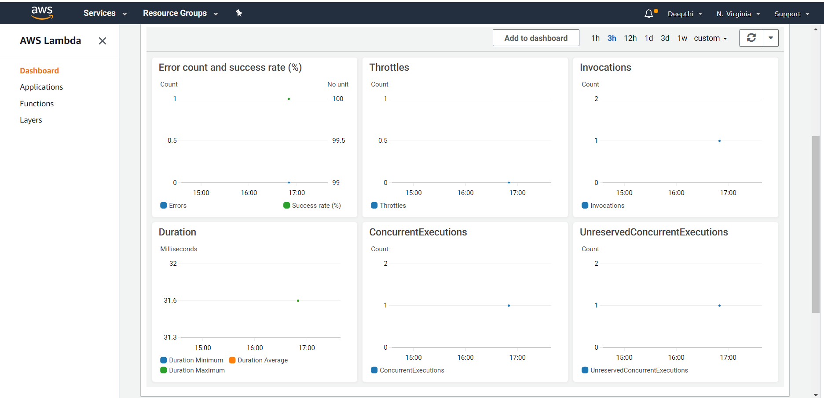 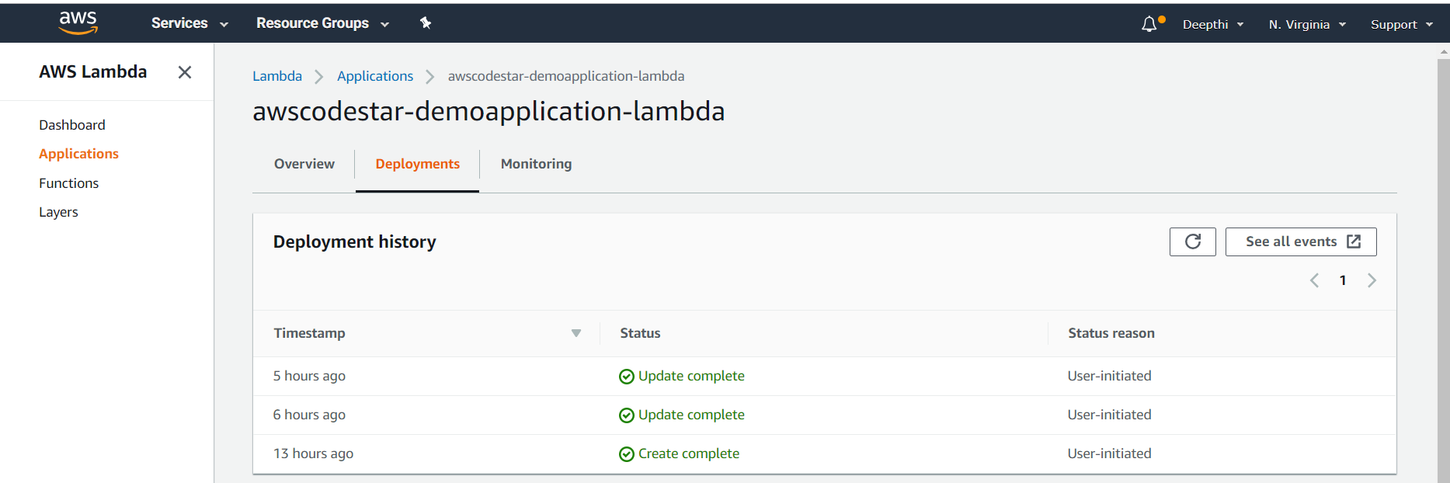

When the deployments are done you can see that the website can be tracked with a number of hits it got in the given time along with that you can also track what is the response time of the website. The insights even give the measure of active time the people spent on the website where we can see the peak time of the people visiting the website.

The insights give real value to the business which helps the company to plan the strategies of the business like time of the offer and what people need etc. This takes the business to the other level which would not be possible if the company is following the traditional web application development and deployment on its own server. Adaption of technology is much important along with that upgrading the technology is also important.

# Analysis and Discussion

There are different ways to compare and analyze the available services in the market. I want to mainly focus on 5 different things which are needed to be considered when someone wants to set up the business and need to analyze the products.

1. Compute Engine and available services from Microsoft, Amazon, and Google
2. Storage services and facilities provided from AWS, Google and Azure
3. Key Cloud Tools Provided by AWS Microsoft and Google
4. The pricing Details and methods from AWS Microsoft and Google
5. Downtime of the service providers.Platform-wise comparison based on customer reviews
6. Advantage and disadvantage of choosing the services

The General basic comparisons:

* **Amazon Web Services**

AWS is growing exponentially along with the growth of the tools upon which the Amazon capability can be unmatched in the market. Its huge structures and cost can confuse the customer and it is more the complex. AWS is more concentrated on the public cloud rather than hybrid or private which means that interoperating with your [data center](https://www.datamation.com/data-center/what-is-data-center.html) isn't AWS's top priority.[][]

* **Microsoft Azure**

Microsoft Azure has good capability in Cloud infrastructure which gives true competition to AWS. Enterprise consumers who are using Microsoft products like OS, Tools, etc could lean more towards the Azure. It is not that complex and not hard to understand its structure compared to AWS upon which Azure knows the enterprise companies do run their own data center so the Azure more concentrates on Hybrid cloud than others which its true strength.

* **Google Cloud**

A well-funded underdog in the competition, Google entered the cloud market later and doesn't have the enterprise focus that helps draw corporate customers. But its technical expertise is profound, and its industry-leading tools in [deep learning and artificial intelligence](https://www.datamation.com/applications/deep-learning-and-artificial-intelligence.html), [machine learning](https://www.datamation.com/big-data/what-is-machine-learning.html), and [data analytics](https://www.datamation.com/big-data/big-data-analytics.html) are significant advantages.

|  |  |  |  |
| --- | --- | --- | --- |
|  | **AWS** | **Microsoft Azure** | **GOOGLE** |
| **Started** | 2006 | 2010 | 2011 |
| Availablity zone | 55+8 | 44+12 | 18+3 |
| **Market Share** | 40 | 30 | 10 |
| **Who is using them** | Netflix,Airbnb,bmw,samsung,mi | honey well,apple,adobe,HP | target,Dominos,HSBC,Paypal,20th century fox |
| **Down Time** | 2014(2 hrs 89 min | 39 hrs | 14 mins |

1. **Compute Engine and available services from Microsoft, Amazo, and Google**

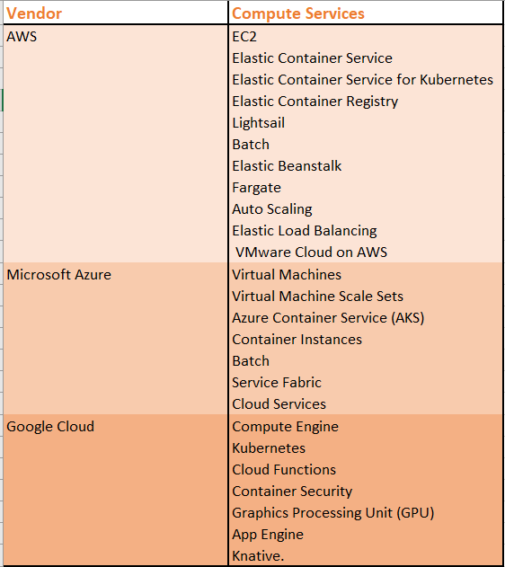

***AWS Compute:***

* **Elastic Compute Cloud:**

EC2 Elastic Compute Cloud2 is the flagship service of Amazon. EC2 description given by Amazon ” a web service that provides secure, resizable compute capacity in the cloud” Ec2 have a various category of option which includes a huge assortment of instances, support for both Windows and Linux, bare metal instances, GPU instances, high-performance computing, auto-scaling and much more.EC2 have a free-tire which comes for 750 hours per month for 12 months but still be sure under this instance there area large sector of services which are chargeable and be sure while using those services if you want free-tire for POC(Proof of concept)

**Container services:**

Amazon offers a variety of container services which are having step curve of highness in the popularity, These containers offer large options towards Docker, Kubernetes and it has its own Fargate service that automates server and cluster management when using containers. It has also offered one for the private cloud which is called Lightsail- which is batch for batch computing jobs. There is Elastic Bean stack which is used for keeping the Web application and scaling them along with keeping track of them for business continuity.

***Microsoft Compute:***

* **Virtual Machines:**

**The primary computing machines of Microsoft are known as Virtual Machines. This extends more support for Linux, Windows Server,** SQL Server, Oracle, IBM, and SAP upon which security could be trusted. The Hybrid cloud capabilities and integrated support for Microsoft software come in addition. It also has Large Catalog of the instances which include GPU and high-performance computing options which can be optimized for AI and ML. Microsoft also offers 750 hours per month of Virtual machines with One Operating system (Linux, Windows, BIS) for a year.

**Additional Services:**

Azure's version of Auto Scaling is known as Virtual Machine Scale Sets. And it has two container services: Azure Container Service is based on Kubernetes, and Container Services uses Docker Hub and Azure Container Registry for management. It has a Batch service, and Cloud Services for scalable Web applications is similar to AWS Elastic Beanstalk. It also has a unique offering called Service Fabric that is specifically designed for applications with microservices architecture.

***Google Compute:***

* **Compute Engine**

The main service from Google is Google Engine which can have both custom and predefined machines. The billing is mainly donned on per second basis. They support Linux and Windows, carbon-neutral infrastructure that uses half the energy of typical data centers. Google in short of services compared to other competitors but they are giving the right difficult competition for them by providing more speed processors. It also has a free tire which has f1-micro instance free per month with limited usage value for 12 months

* **Focus on Kubernetes**

Kubernetes Engine for organizations is also offered by Google for the companies who are interested in the containers. Same like other vendors google also offers containers in micro instances. Google has been involved itself more in the Kubernetes project, giving it extra expertise in this area.

1. **Storage services and facilities provided from AWS, Google and Azure**

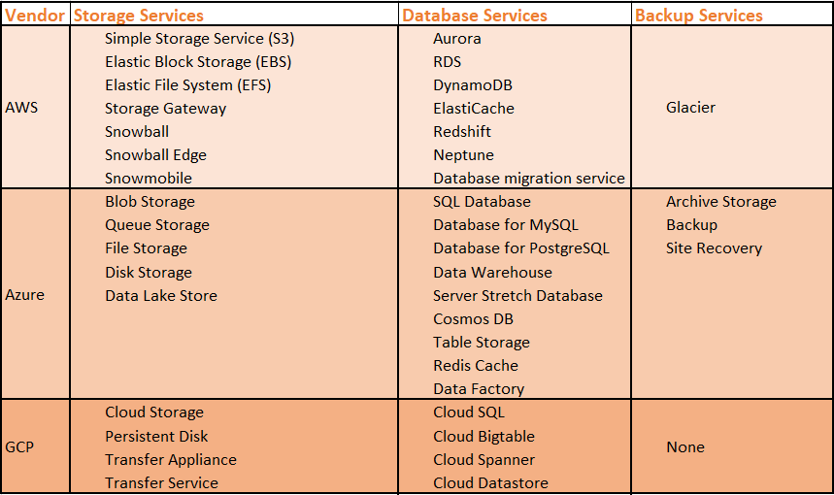

***AWS Storage***

* **SSS to EFS**

There are many storage services which are provided by the AWS which include S3 which comes for the free tire and used for object storage. EBS[Elastic Block Storage] which is used for the block storage with EC2 instances, EFS[Elastic File System] is for file storage. There are some storage facilities which are innovative and enables hybrid storage environment which includes storage Gateway and snowball, Snowball is the hardware device which is specifically for the organization who can not have the internet connection and want to transfer the data. It has the capability to transfer the data in petabytes

* **Database and archiving**

Aws supports a large set of the database than any other competitors which makes it more flexible and easy to choose as it is easy to migrate if the system might need of migration in the future. Some of the databases have its own version but the flavor of the original database structure like Amazon has SQL compatible database version called Aurora RDS, DynamoDB NoSQL database, ElastiCache in-memory data store, Redshift data warehouse, Neptune graph database, and a Database Migration Service. Amazon also offers low priced long term archival storage which is Amazon Glacier, upon which the setup process of set up backup and archive processes is easy with Storage Gateway. The process of setting up the storage and database archiving is made easy by the introduction tutorial

***Azure Storage:***

* **Storage Services**

Microsoft does not provide a lot of storage services like Amazon and it sticks to the support of its own services which is Microsoft origins. The basic services are given for Blob Storage for REST-based object storage of unstructured data, Queue Storage for large-volume workloads, File Storage and Disk Storage. For big data and its applications, it has its own version which is Data Lake store

* **Database**

Database support from the Azure is more wide range than storage. It has 3 kinds of database which it supports which are SQL-based options( SQL Database, Database for MySQL and Database for PostgreSQL). The data warehouse service is also provided by the Azure along with support for Cosmos DB and Table Storage for NoSQL can also be taken. In-Memory service is provided from Redis Cache. Hybrid storage service is designed specifically for organizations that use Microsoft SQL Server in their own data centers for which they provide the service through Server Stretch Database. Microsoft has proportionally bigger in an aspect of the database as they are into this field from a long time so they have a good service along with actual Backup service, as well as Site Recovery service and Archive Storage.

***Google Storage:***

* **Unified Storage and more**

Google Have very fewer options available even for storage. Cloud Storage is its unified object storage service, and it also has a Persistent Disk option. Google also offers Transfer Appliance similar to AWS Snowball, as well as online transfer services.

* **Database**

For Databases, Google has come up with SQL based Cloud-based SQL and for Relational Databases, there is Cloud Spanner that is designed for mission-critical workloads. For Bigdata and Data stores they offer Cloud table and Cloud Datastore. It doesn’t have a backup and any archive services.

1. **Key Cloud Tools Provided by AWS Microsoft and Google**

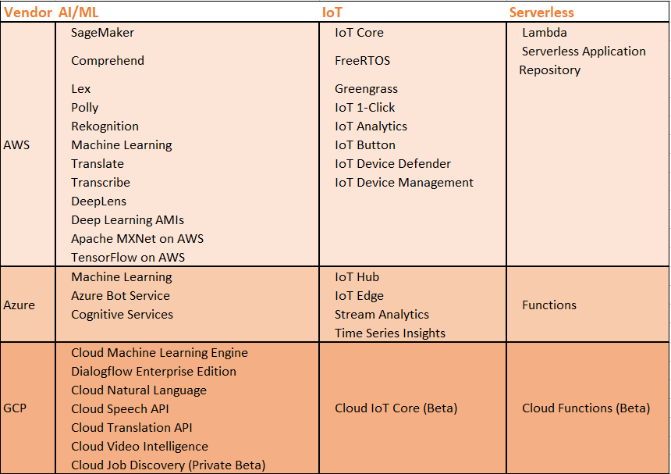

***AWS Key Tools:***

* **Sage maker to Serverless**

Aws has the largest set of services available in the market which include serverless applications which I have deployed in the aws which uses AWS LAMBA for running AWS. The huge set of AI and ML for training and deploying machine learning models and services which are available through Sage maker. It also Provides IOT messaging services[Green grass]

* **AI and ML**

**There is a huge range of services listed for AI and ML. Among them, for OCR [OpticalCharacter Recognition] and for** image and object recognition **it uses** DeepLens, an AI-powered camera**. AWS has made the life easier to lot many people who don’t know about the neural network can also jump in and start building the application with much ease along with training the neural network without even programming skills of AI. These can be done using AWS launched** Gluon, an open source deep learning library.

***Azure Key Tools:***

* **Cognitive Services**

Microsoft is also not behind in providing the AI or ML services for which it has invested pretty heavily. It also has Cognitive Services that include a Bing Web Search API, Computer Vision API, and Custom Vision Service, Text Analytics API, Face API. It has its own kind of serverless computing service which is Functions.

* **Supporting its own Software’s to be on cloud**

All of the Microsoft services are tied up and it gives a lot more leverage of choosing Azure if you are using Microsoft product like if you have windows server azure provides the good Azure Backup is a service that links Windows Server Backup in Windows Server 2012 R2 and Windows Server 2016. It also provides and makes the application and developers life easier by giving

***Google Key Tools:***

* **Bigdata on AI**

Google has been focusing on the AI and Machine Learning areas with a long persistent way for which it could be called as Leader in AI Development. You can see a lot many options in Cloud applications which Google support. TensorFlow, an open source software library which is for building machine learning applications. Google Cloud has also offered APIs for natural language, speech, translation and more.

**IoT to Serverless:** Google Cloud also offers APIs for natural language, speech, translation and more. It also has serverless and IOT which serve the beta versions but the original versions are out in the market for the usage.

1. **The pricing Details and methods from AWS Microsoft and Google**

* **AWS Pricing**

AWS pricing is difficult to predict and manage, So the cost estimator calculators and budget estimators are implemented in the billing itself in which refers to the cost incurred for the specifications used. The third party cost management tools could be preferred because the structure of cost management is highly complex.

* **Azure Pricing**

Microsoft Azure is not either simpler. As Microsoft products complicated software licensing options and use of situation-based discounts, its pricing structure is difficult to comprehend without external assistance or substantial experience.

* **Google Pricing**

Google, on the other hand, provides a quite understandable and differentiation structure which would be easier to comprehend and understand them. Google provide huge discounts and flexible contracts which makes it customer friendly and high stick competition to the market in the current situation.

Before deciding on any vendor organizations must keep themselves updated regularly as the prices, offers and service structures are frequently updated. So to get the best deal from vendors the consumers must be aware of current rates and forecast.

1. **Downtime of Amazon, Microsoft, and Google[][]**

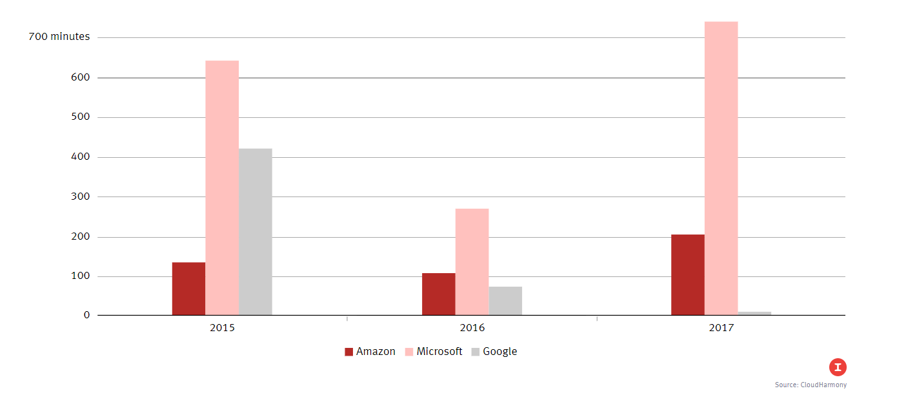

As we can see in the graph the downtime of Microsoft Azure has increased prominently so, If the application on the cloud which is time constraint and health-related software or any software which has a major concern with the downtime of the application. Google Cloud has a prominent decrease in the downtime which could be considered but again the next would be the location where all you need the service from. As Google is still expanding it is in fewer places. If the application needs server location and loads distributed along the global stretch then AWS cloud be considered

1. **Platform-wise comparison based on customer reviews*[18]***

**The platform wise comparison is done with the following structure**

* **Platforms in the market are compared with** 
  + - **Trending Vendors in the market**
    - **Reviews**
    - **Business structures[small medium big]**

**IaaS Platforms:**

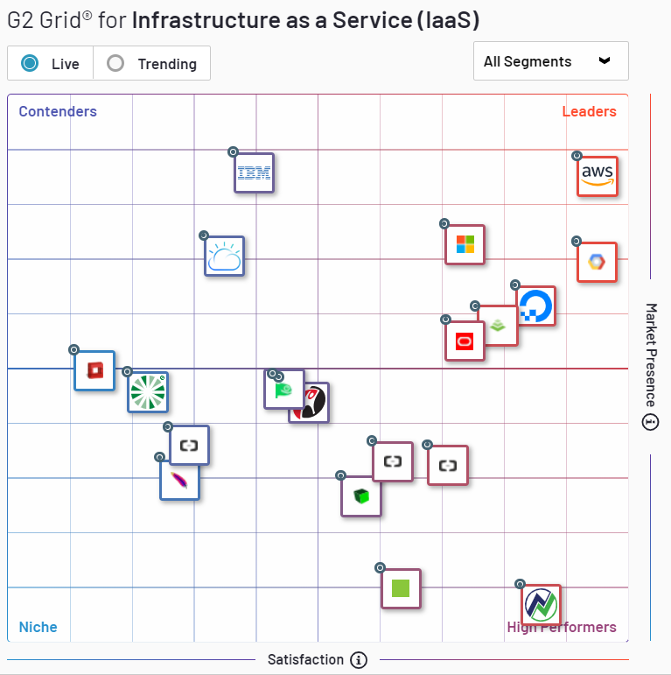 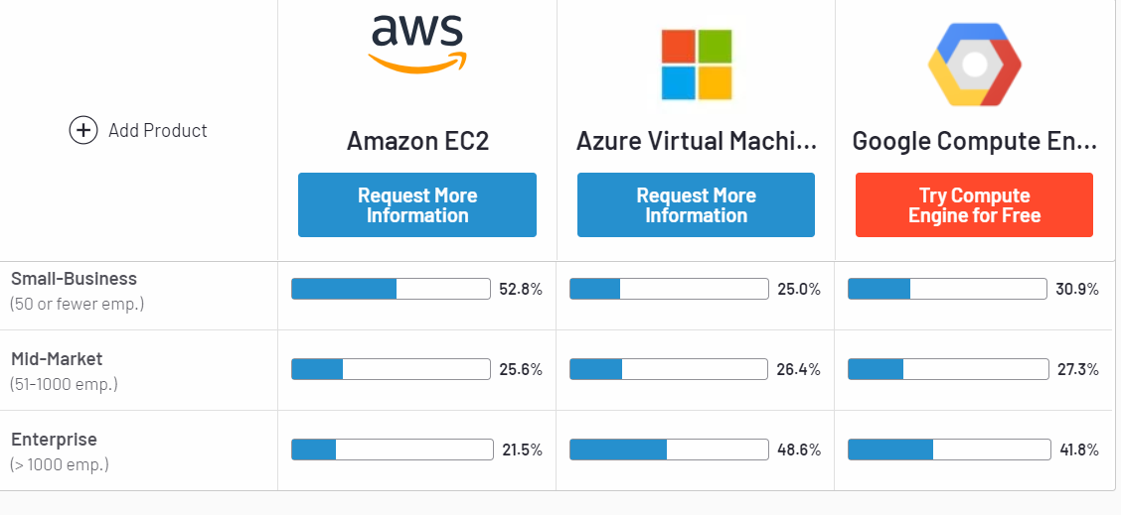 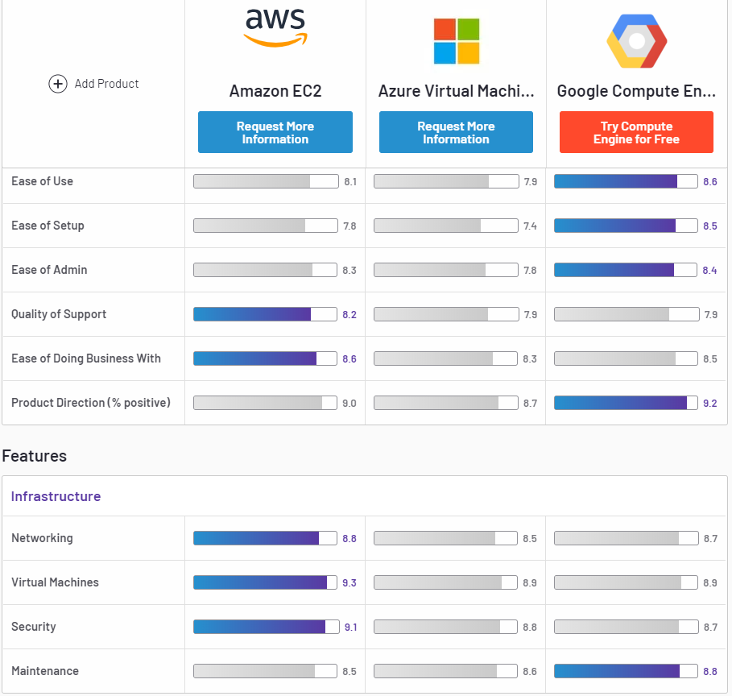

* **Trending Vendors in the market**

There are several platforms Aws provides for IaaS among them AWS EC2 is one. Azure virtual machines are one for the Iaas from Microsoft and Google compute is from Google. All of these can be compared with quality, easiness, support and etc. There are several other Iaas Providers in the market other than the AWS, Google, and Microsoft which are shown in the G2 Grid wherein we can see that IBM and IBM Cloud foundry also pitched to the level of aws in the market where they are still contenders. Oracle Cloud, Digital ocean are among others which are giving fair competition to the giants in the area

* **Reviews:**

As per the Reviews in the market, we can see that Google stands better in set up, easy and use and monitor but fails to gain its place for support and business retrieval from Google. Aws is quite complex in structure and needs experienced people to handle it. Aws falls behind even in giving the product the right direction. Microsoft falls behind the screens in all the issues which makes it less little worth in the market but would be the good fit than once they improve their performance and support.

* **Business structures[small medium big]**

As we can see in the graph of G2 the Aws stands at the top of the Grid in Small, Medium business structures but at the enterprise level, IBM stands out leaving behind AWS, Microsoft and Google cloud.

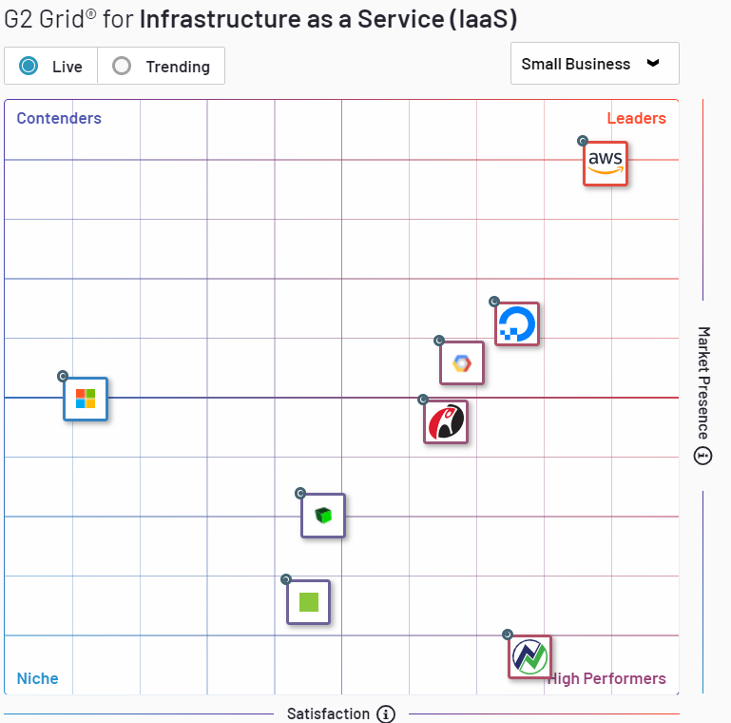 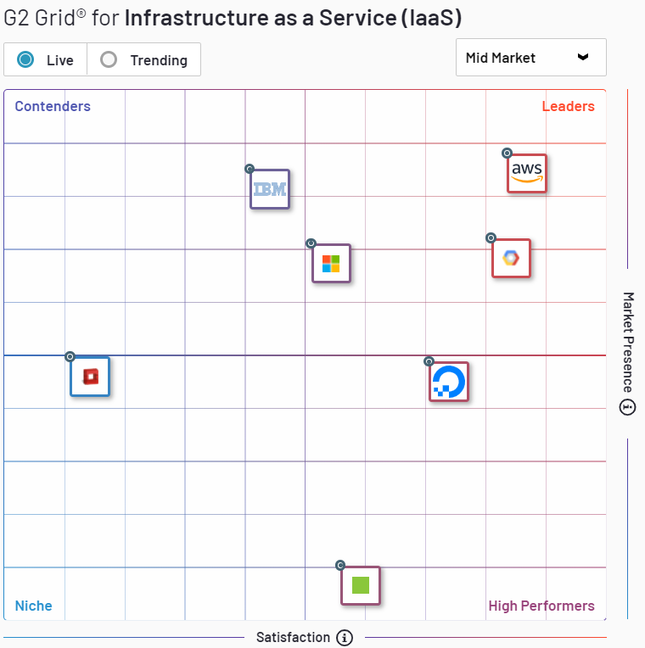 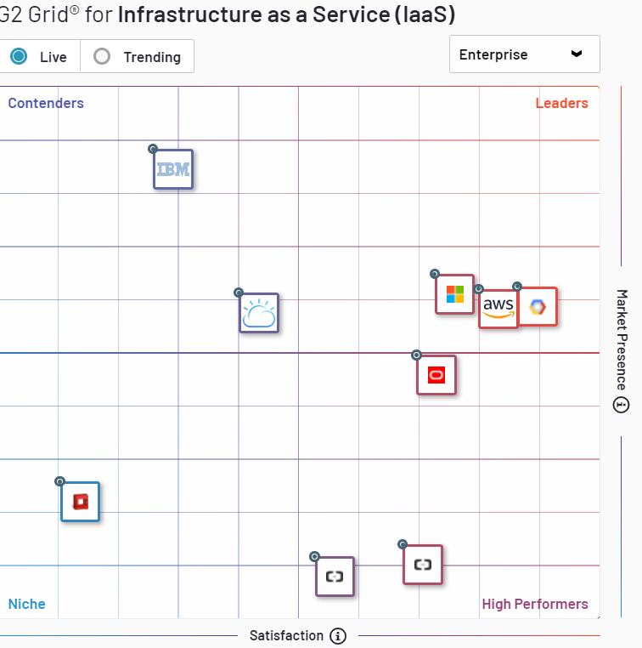

PaaS

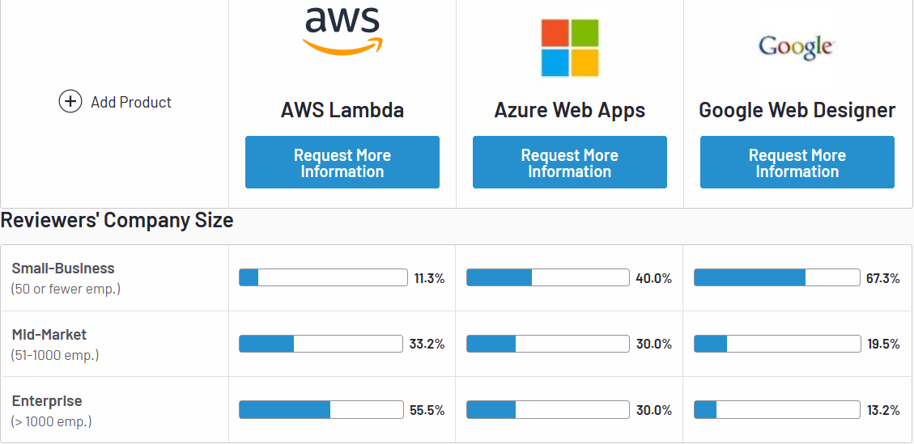 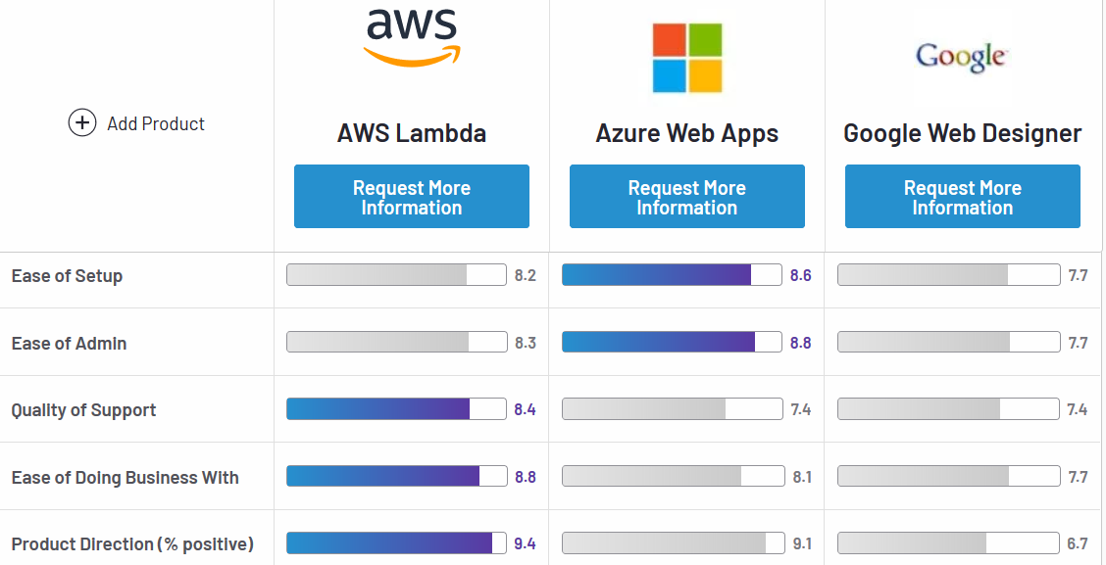 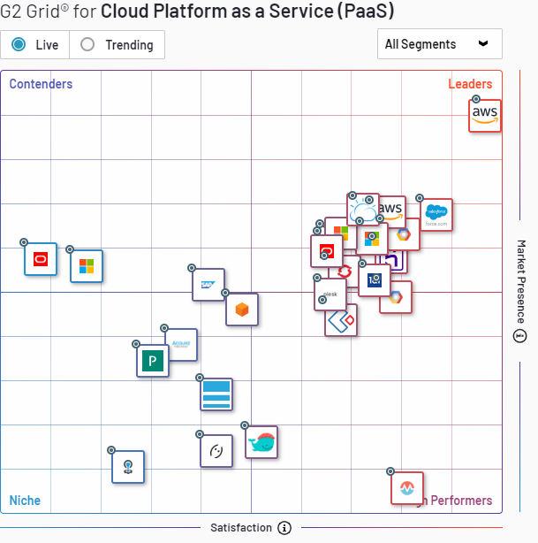

There are several platforms Aws provides for PaaS among them AWS Lambda is one. Azure Web Apps is one of the Paas from Microsoft and Google Web designer is from Google. All of these can be compared with quality, easiness, support and etc. There are several other Paas Providers in the market other than the AWS, Google and Microsoft which are shown in the G2 Grid wherein we can see that salesforce, IBM cloud foundry also pitched to the high level same as aws in the market. Oracle, SAP are among others which are giving fair competition to the giants in the area

* **Reviews:**

As per the Reviews in the market, we can see that Microsoft stands better in set up and monitor but fails to gain its place for support and business retrieval from Microsoft. Aws is quite complex in structure and needs experienced and certified people to get hands-on with it. If right people are backed up in this environment for AWS can reap good results for the business and need not worry for the support and its really easy to find and learn the solution using aws. Google falls behind the screens in all the issues which makes it less little worth in the market but would be the good fit than aws once it is completely acquiring the market with its capabilities.

* **Business structures[small medium big]**

As we can see in the graph of G2 the Aws stands at the top of the Grid not only in Small and medium business structures but also at the enterprise level business level. IBM stands out leaving behind all others with contending the competitors for medium business, though Google stays close by to compete with it.

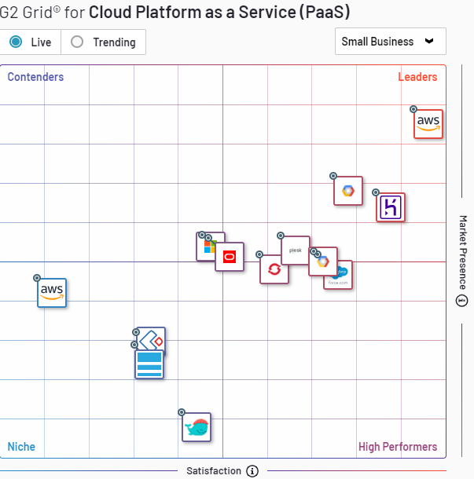 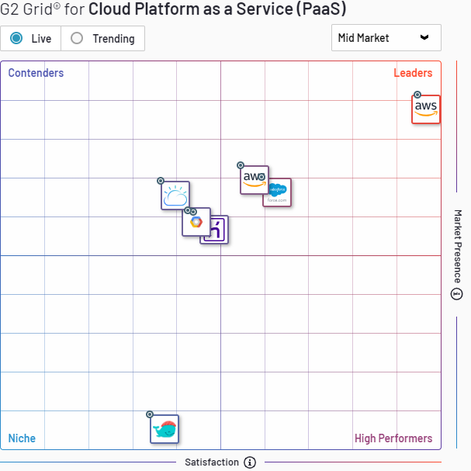 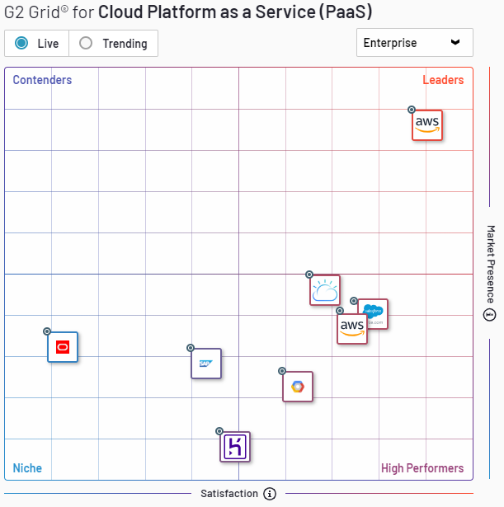

1. **Strength and Weakness of vendors**

### *AWS*

Strength:

Amazon has the dominance in the public Cloud market. In its [Magic Quadrant for Cloud Infrastructure as a Service, Worldwide,](https://www.gartner.com/doc/reprints?id=1-2G2O5FC&ct=150519&st=sb&aliId=1154870580) Gartner noted, "AWS has been the market share leader in cloud IaaS for over 10 years."

Amazon holds the place of popularity as it has grown massively from the past years and it is still keeping its pace to improve and add the services to the list. Along with the availability of the services worldwide makes it more reverent among its competitors. Aws has the most mature platform than any other in the market which gives it the capability to govern the huge number of users and resources

Weakness:

Amazon drawback lies within it which is cost. It has cost irregularity which makes the consumers difficult to understand its pattern and run the cost-effective system when they choose Amazon

Over the end one can be overshadowed by Amazon's strengths and the organizations of all sizes can choose and use AWS for a wide variety of workloads.

### *Microsoft Azure*

Strength:

Microsoft entered little late to the market but supporting its own products to be on a cloud made its software’s easier to deploy and maintain and with at its ease which reassures the compatibility and wins customers by this it still stays strand which cannot be upturned in the market.

The biggest strength of Azure is it has many software’s which are deployed and maintained on the windows which can gain the strength to move to the cloud and it makes it even easier by giving just a plugin and few steps to follow. This builds loyalty for existing Microsoft customers. Also, if you are already an existing Microsoft enterprise customer, expect significant discounts off service contracts.

Weakness:

The main week ness of Azure is that it is not completely enterprise level and there are in short and less responsive towards the technical support, documentation, training, and breadth of the ISV partner ecosystem.

### *Google*

Google is offering good quality of service and platforms which include containers, Kubernetes. GCP is focused on high compute offerings like Big Data, analytics, and machine learning. It also has good scale and load balancing – Google is known for data centers and fast response time.

# 6. Conclusion and Lesson Learned

With the High competition in today’s multi-cloud world, there is no one who wins the game for a long period everyone is consistent in their performance and improvement. Google can be good if the computation requirement is too high and the application needs high responsive time. If the Cloud service needs the key categories of storage, compute, and management tools, AWS and Azure offer a more efficient and mature stack than Google. Considering the opting for one of the services needed for some application, It could be extended from the same service if there is already exists in other departments would save a lot of money and fits the budget. On the other hand, if the company is having a large set of Microsoft Products usage and tools involved it's better to go with the Azure as its really convenient and essay to maintain and obtain the service.

Based on the budget, Organization level competencies needed one can choose the better service which would be good for their business and excel by moving towards the cloud.

# 7. References

[1]<https://doi.org/10.1016/j.procs.2017.05.375>

[2] [https://doi.org/10.1016/j.jnca.2010.07.006](https://doi-org.liblink.uncw.edu/10.1016/j.jnca.2010.07.006)

[3] http://csrc.nist.gov/publications/nistpubs/800-145/SP800-145.pdf

[4] [International Journal of Cloud Computing and Services Science](https://search-proquest-com.liblink.uncw.edu/pubidlinkhandler/sng/pubtitle/International+Journal+of+Cloud+Computing+and+Services+Science/$N/1686342/PagePdf/1431101736/fulltextPDF/714497CDFF904A06PQ/1?accountid=14606); Yogyakarta[Vol. 2, Iss. 2,](https://search-proquest-com.liblink.uncw.edu/indexingvolumeissuelinkhandler/1686342/International+Journal+of+Cloud+Computing+and+Services+Science/02013Y03Y01$232013$3b++Vol.+2+$282$29/2/2?accountid=14606) (2013): 148.

[5] <https://www.ripublication.com/acst17/acstv10n5_09.pdf>

[6] Eugene Gorelik- Cloud Computing Modelshttps://edisciplinas.usp.br/pluginfile.php/234466/mod_resource/content/2/2013-01-2.pdf.

[7] Santosh Kumar and R. H. Goudar- Cloud Computing – Research Issues, Challenges Architecture, Platforms, and Applications: A Survey http://www.ijfcc.org/papers/95-F0048.pdf.

[8] Yashpalsing Jadeja, Kirit Modi “Cloud computing concepts, architecture and challenges”, International Conference

on Computing, Electronics and Electrical Technologies [ICCEET] 2012, Kumaracoil, pp.877-880, 2012

[9] <https://pdfs.semanticscholar.org/d6e4/06b503e1c09f3b8a8bf93694988eca12d745.pdf>

[10] Buyya R, Yeo CS, Venugopal S, Broberg J, Brandic I (2009) Cloud computing and emerging IT platforms: Vision, hype, and reality for delivering computing as the 5th utility. Future Gener Comput Syst 25(6):599–616

# [11] C.N. Höfer · G. Karagiannis(2011) Journal of Internet Services and Applications ISSN: 1867-4828 (Print) 1869-0238 (Online)Cloud computing services: taxonomy and comparison

[12] Hilley D (2009) Cloud computing: a taxonomy of platform and infrastructure-level offerings. Tech Rep GIT-CERCS-09-13, CERCS, Georgia Institute of Technology

[13] W. Voorsluys, J. Broberg, and R. Buyya, Introduction toCloud Computing,” Cloud Computing: Principles and Paradigms, chapter 1, pp. 1–41. Technical Report HPL-2002-180, Software Technology Laboratories, HP Laboratories, (2011).

[14] Buyya, R., and Alexida. D. A Case for Economy GridArchitecture for Service-Oriented Grid Computing. In Proceedings of the 10th International HeterogeneousComputing Workshop (HCW), San Francisco, CA, (2001).

[15] Taj Eldin Suliman M. Ali, Hany H. Ammar Pricing Models for Cloud Computing Services, a Survey. International Journal of Computer Applications Technology and ResearchVolume 5– Issue 3, 126 - 131, 2016, ISSN:- 2319–8656

[16] Amazon Web Services. [http://aws.amazon.com](http://aws.amazon.com/)

[17] <https://docs.microsoft.com/en-us/azure/app-service/app-service-web-get-started-dotnet>

[18]<http://www.gartner.com/newsroom/id/3188817>

# 8. Appendices

**application on aws:**

**Application Url:** <https://5yynqkbqh7.execute-api.us-east-1.amazonaws.com/Prod/>

**Initial**

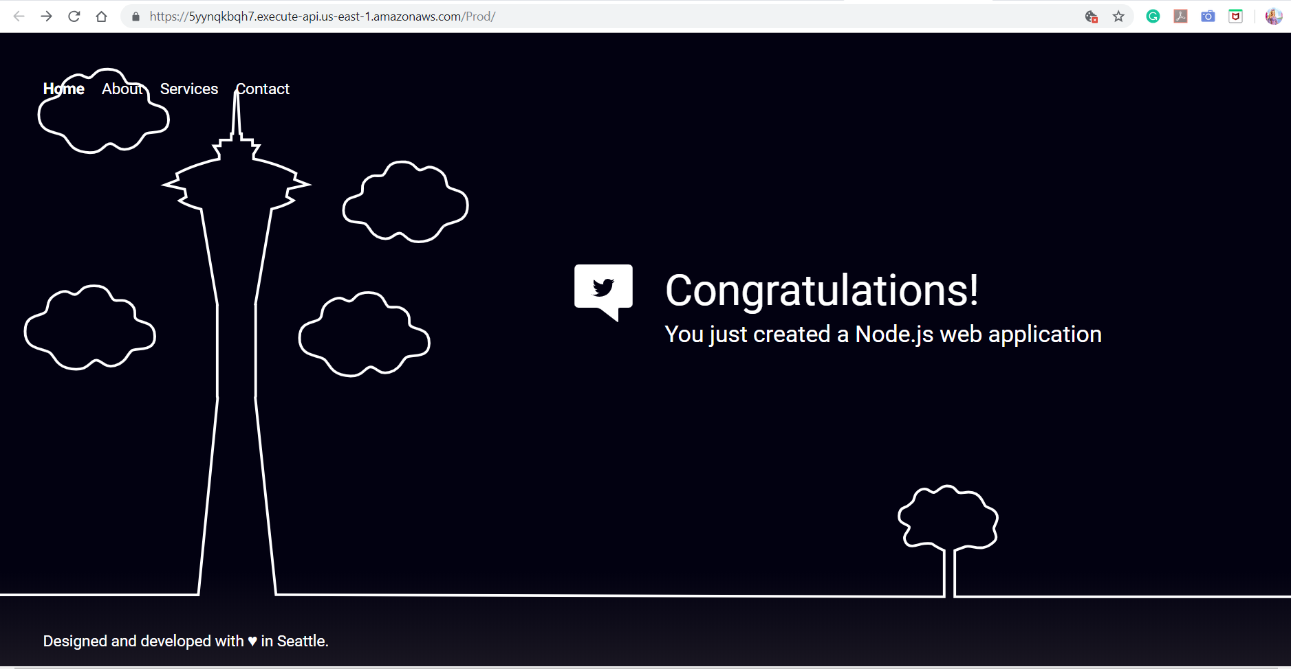

**Modified**

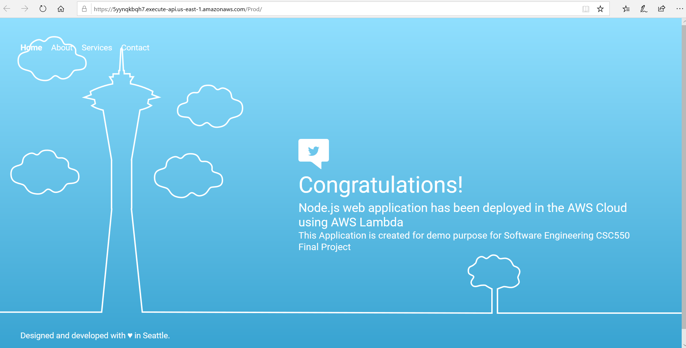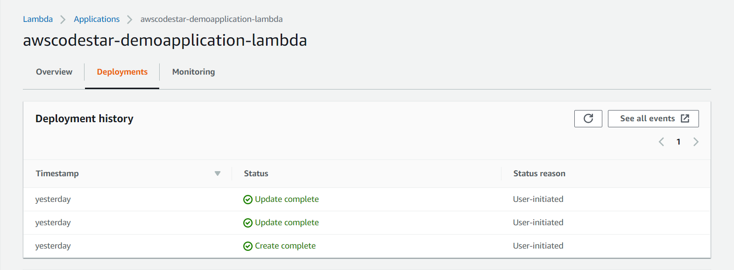

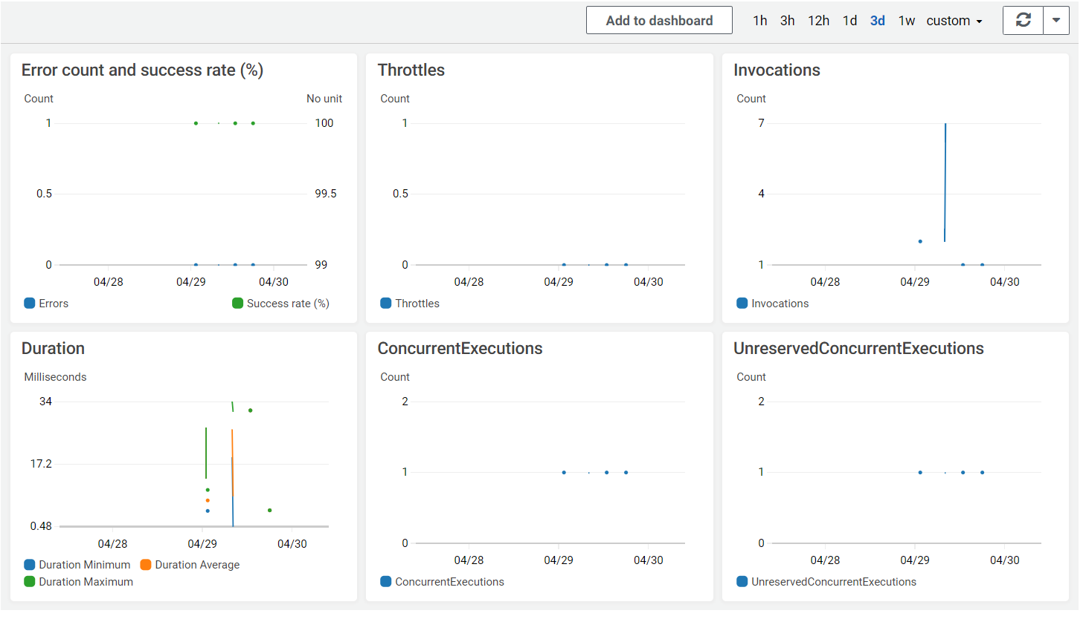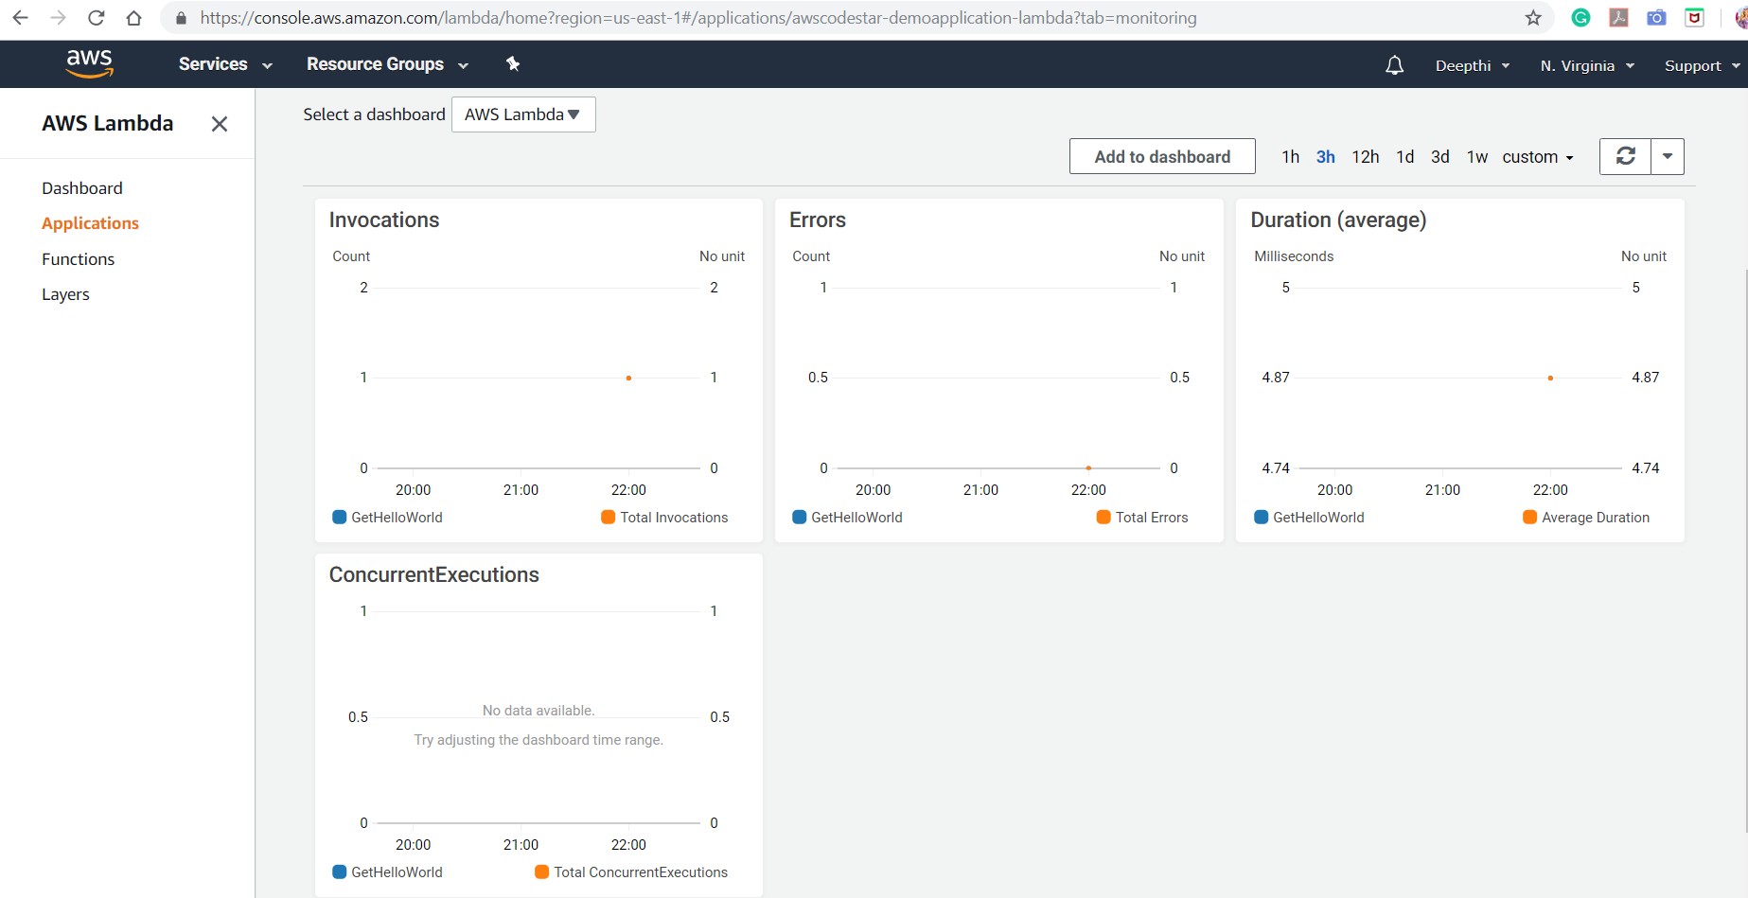

**Azure application deployed:**

<https://webapplication20190414024412.azurewebsites.net/>

